NOD_Codes

Mohit Mehndiratta

27/10/2021

# Iraqi Refugees

## Loading the data

iraqi = c(123, 70, 93, 157)  
aihw = c(70.65, 18.5, 7.41, 3.43)  
levs = c("low", "moderate", "high", "very high")  
names(iraqi) = levs  
names(aihw) = levs  
  
m <- rbind(iraqi,aihw)  
m

## low moderate high very high  
## iraqi 123.00 70.0 93.00 157.00  
## aihw 70.65 18.5 7.41 3.43

## Visualisation

barplot(m, beside = TRUE, col = 2:3,  
 legend.text = c('Refugees', 'Australians'))

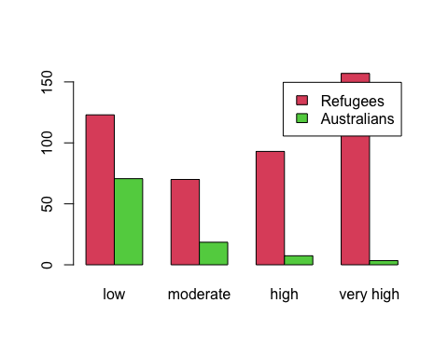

## Hypothesis Testing

H0: There is no difference in distribution of distress between iraqi and aihw H1: There is a difference CV: 0.05

expected = aihw * 443 / 100  
cs <- sum((iraqi - expected) ^ 2 / expected)  
cs

## [1] 1550.75

d <- replicate(5000, {  
 obs <- rmultinom(1, 443, expected)  
 sum((obs - expected) ^2 / expected)  
})  
hist(d, col="lightblue", xlim = c(0,1580))  
abline(v = cs, col = "red")

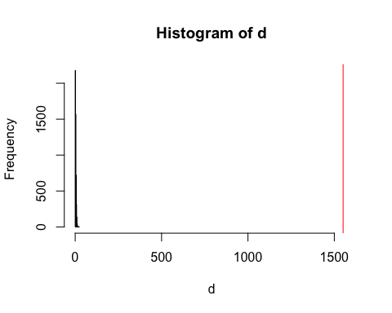

pVal <- mean(d > cs)  
pVal

## [1] 0

And another method for hypothesis testing

chisq.test(iraqi, p = aihw, rescale.p = TRUE, simulate.p.value = TRUE, B = 5000)

##   
## Chi-squared test for given probabilities with simulated p-value (based  
## on 5000 replicates)  
##   
## data: iraqi  
## X-squared = 1550.6, df = NA, p-value = 2e-04

# Eye Color:

## Loading the data:

male = c(98, 101, 47, 33)  
female = c(122, 114, 46, 31)  
levs = c("Brown", "Blue", "Hazel", "Green")  
names(male) = levs  
names(female) = levs  
  
m <- rbind(male,female)  
m

## Brown Blue Hazel Green  
## male 98 101 47 33  
## female 122 114 46 31

## Visualisation

barplot(m, beside = TRUE,col = c("Royalblue", "indianred"),  
 main = "Distribution of Eye Colours",  
 ylab = "Number of Occurrences",  
 legend = TRUE)

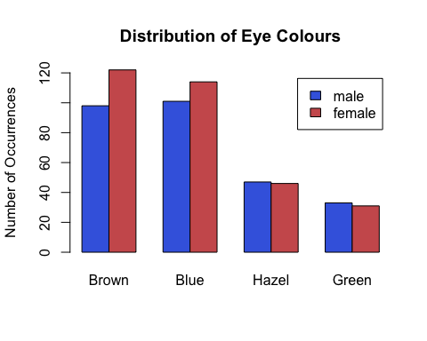

## simulation

chisq.test(m, rescale.p = TRUE, simulate.p.value = TRUE, B = 5000)

##   
## Pearson's Chi-squared test with simulated p-value (based on 5000  
## replicates)  
##   
## data: m  
## X-squared = 1.5298, df = NA, p-value = 0.6801

# EELS

## Loading the data:

eels <- matrix(c(264, 161, 127, 116, 99, 67), ncol = 3)  
  
speciesLabels <- c('G.moringa', 'G.vicinus')  
locationLabels <- c('Border', 'Grass', 'Sand')  
  
dimnames(eels) <- list(species = speciesLabels,  
 location = locationLabels)  
eels

## location  
## species Border Grass Sand  
## G.moringa 264 127 99  
## G.vicinus 161 116 67

sampleSize = sum(eels)

## Visualisation:

eels1 = eels ## Proportions  
eels1[1,] = eels[1,] / sum(eels[1,])  
eels1[2,] = eels[2,] / sum(eels[2,])  
eels1

## location  
## species Border Grass Sand  
## G.moringa 0.5387755 0.2591837 0.2020408  
## G.vicinus 0.4680233 0.3372093 0.1947674

barplot(eels1, beside = TRUE,col = c("Royalblue", "indianred"),  
 main = "Distribution of Eels",  
 ylab = "Number of Occurrences",  
 legend = TRUE)

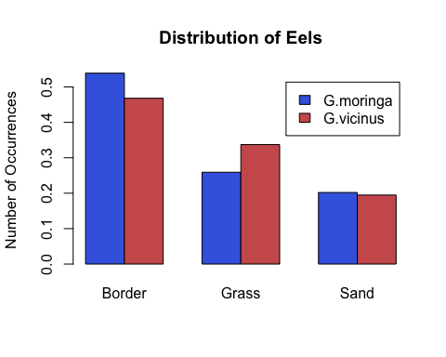

## Simulation

speciesCount = rowSums(eels)  
locationProps = colSums(eels) / sampleSize  
  
# our expected distribution  
exp <- outer(speciesCount, locationProps)  
  
cs <- sum((eels - exp)^2 / exp)  
# Simulate / the distribution of differences  
#  
# simulate the data, assuming that the species  
# does not effect the location  
speciesProps <- speciesCount / sampleSize  
  
d <- replicate(5000, {  
 # sample of species  
 sp <- sample(speciesLabels,  
 size = sampleSize,  
 replace = TRUE,  
 prob = speciesProps)  
   
 # sample of locations  
 lc <- sample(locationLabels,  
 size = sampleSize,  
 replace = TRUE,  
 prob = locationProps)  
   
 # tabulate the results  
 res <- table(sp, lc)  
   
   
 # re-compute the expected  
 r <- rowSums(res)  
 c <- colSums(res) / sum(res)  
   
 ex <- outer(r, c)  
   
   
 # compute diff between sample and expected  
 sum((res - ex)^2 / ex)  
})  
  
hist(d, col="lightblue")  
abline(v = cs, col = "red")

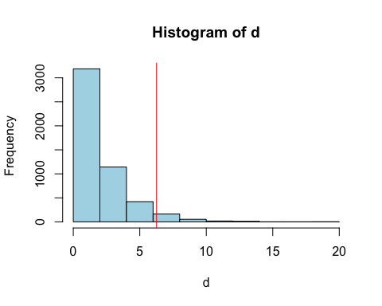

pVal <- mean(d > cs)  
pVal

## [1] 0.0444

chisq.test(eels, simulate.p.value = TRUE, B = 5000)

##   
## Pearson's Chi-squared test with simulated p-value (based on 5000  
## replicates)  
##   
## data: eels  
## X-squared = 6.2621, df = NA, p-value = 0.04899

# Card Piles

## Simulation

x1 <- sample(1:52)  
x2 <- sample(1:52)  
  
# x1 <- x2 with this commented out, x1 and x2 are different, otherwise identical  
  
cs <- sum((x1 - x2)^2)  
  
# Simulate what is supposedly random  
d <- replicate(1000,  
 {  
 a <- sample(1:52)  
 b <- sample(1:52)  
   
 sum((a - b)^2)  
 })  
  
hist(d)  
abline(v = cs, col = 2, lwd = 2, lty = 2)

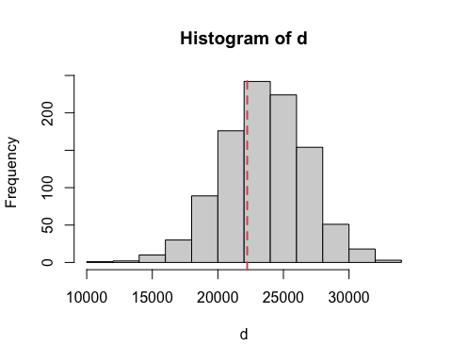

## Birth Weight

## Loading the data

birthWeight <- read.csv("../datasets/birthwt.csv")  
head(birthWeight)

## bwt smoke  
## 1 3429 no  
## 2 3229 no  
## 3 3657 yes  
## 4 3514 no  
## 5 3086 yes  
## 6 3886 no

table(birthWeight$smoke)

##   
## no yes   
## 742 484

summary(birthWeight)

## bwt smoke   
## Min. :1571 Length:1226   
## 1st Qu.:3114 Class :character   
## Median :3429 Mode :character   
## Mean :3415   
## 3rd Qu.:3743   
## Max. :5029

aggregate(bwt~smoke, birthWeight, mean)

## smoke bwt  
## 1 no 3515.639  
## 2 yes 3260.285

## Visualisation

boxplot(bwt~smoke, birthWeight, col = c(7,5), horizontal = TRUE)

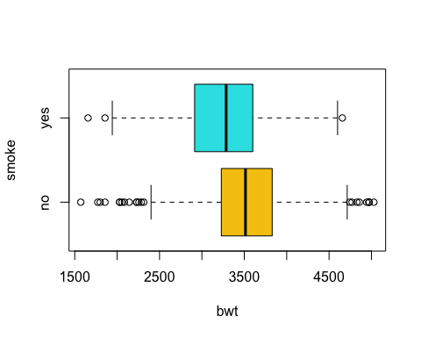

## Hypothesis Testing

# H0: mu1 == mu2, There is no difference  
# H1: mu1 < mu2, There is a difference  
  
delta <- aggregate(bwt ~ smoke, birthWeight, mean)$bwt  
delta

## [1] 3515.639 3260.285

cs <- -diff(delta)  
  
d <- replicate(5000, {  
 smoke.shuffle <- sample(birthWeight$smoke)  
 del <- aggregate(bwt~smoke.shuffle, birthWeight, mean)$bwt  
 -diff(del)  
})  
  
hist(d, main = '', col = 'skyblue', xlim = c(-1, 1) * 300)  
abline(v = cs, col = "red", lwd = 2, lty = 2)

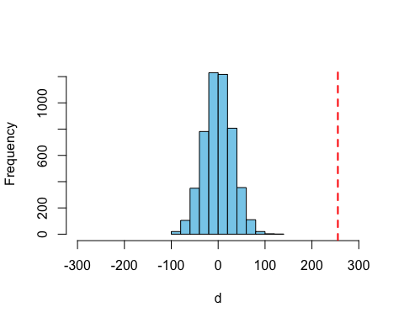

# One sided test, so p-value calculation uses one side of the distribution  
# The +ve side is used since mu2 - mu1 > 0  
pVal <- mean(d > cs)

# Drugs Data

## Loading the data

# Loading the drug data from file "assignmentB_drugData.csv".  
drug_data <- read.csv("../datasets/drugs.csv")  
head(drug_data) # viewing the first 6 rows of the data

## response drug  
## 1 8.661020 new  
## 2 11.431452 new  
## 3 13.904322 ref  
## 4 8.300664 new  
## 5 14.662067 new  
## 6 9.971347 ref

## Visualisation

## Visualisation  
boxplot(response~drug, data = drug_data, pch = 16,  
 col = c("cornflowerblue","orange"))

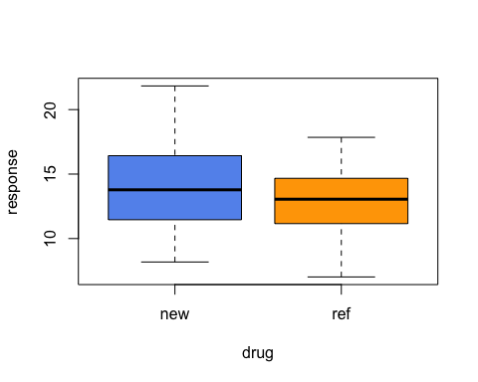

## Hypothesis Testing

# For the Hypothesis, we are using null and alternate hypothesis as follows:  
  
# H0: mu1 == mu2, There is no statistically significant improvement exist for new drug over ref drug.  
# H1: mu1 > mu2, There exists a statistically significant improvement for new drug over ref drug.  
# CV = 0.05 (5%)  
  
cv <- 0.05 # critical value  
replications <- 5000 # number of replications for simulation  
  
# calculating mean data for new drug and ref drug  
delta <- aggregate(response ~ drug, drug_data, mean)$response  
  
# Calculating difference in means  
cs <- -diff(delta)  
  
cat("Difference in means of new drugs and ref drugs is:", cs, "\n")

## Difference in means of new drugs and ref drugs is: 1.088462

# setting the seed value.  
set.seed(2)  
# Simulating the difference in means by 5000 times for the shuffled drug categories within same data.  
d <- replicate(replications, {  
 shuffled_drug <- sample(drug_data$drug) ## Shuffling the drug categories  
 delta <- aggregate(response ~ shuffled_drug, drug_data, mean)$response  
 c <- -diff(delta)  
})  
  
cat("Average difference in means for simulated results",mean(d), "\n\n")

## Average difference in means for simulated results -0.009275686

# Visualising the simulated outcome  
hist(d, col = "lightblue", main = "Distribution of difference in means")  
abline(v = cs, col = "red", lwd = 2)

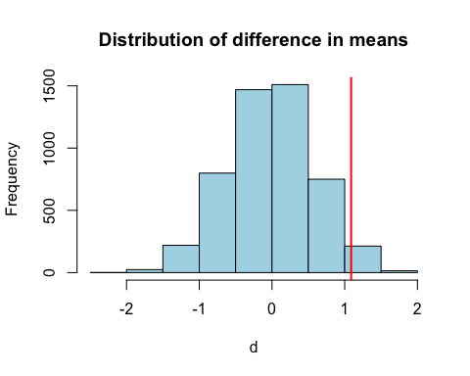

# counting the number of replications which have bigger difference than original difference.  
count <- sum(d > cs)  
  
# calculating p-value  
pvalue <- count/replications  
cat("Calculated p-value from the simulation:", pvalue, "\n\n")

## Calculated p-value from the simulation: 0.0348

cat("Is critical value greater than p-value?", cv > pvalue, "\n")

## Is critical value greater than p-value? TRUE

## if true then reject the null hypothesis.

# Spider Data set

## Hypothesis testing

spider <- read.csv("../datasets/Spider.csv")  
head(spider)

## Group Anxiety  
## 1 Picture 30  
## 2 Picture 35  
## 3 Picture 45  
## 4 Picture 40  
## 5 Picture 50  
## 6 Picture 35

table(spider$Group)

##   
## Picture Real Spider   
## 12 12

summary(spider)

## Group Anxiety   
## Length:24 Min. :25.0   
## Class :character 1st Qu.:35.0   
## Mode :character Median :42.5   
## Mean :43.5   
## 3rd Qu.:50.0   
## Max. :65.0

aggregate(Anxiety~Group, spider, mean)

## Group Anxiety  
## 1 Picture 40  
## 2 Real Spider 47

boxplot(Anxiety~Group, spider, col = c(7,5), horizontal = TRUE)

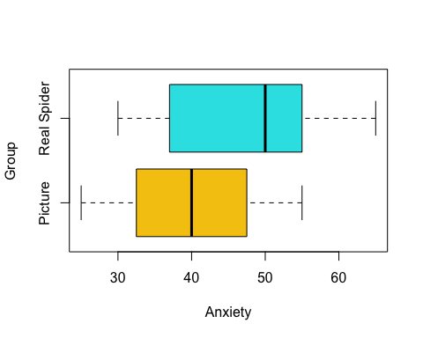

# H0: mu1 == mu2, There is no difference  
# H1: mu1 < mu2, There is a difference  
  
delta <- aggregate(Anxiety~Group, spider, mean)$Anxiety  
delta

## [1] 40 47

cs <- diff(delta)  
  
d <- replicate(5000, {  
 Group.shuffle <- sample(spider$Group)  
 del <- aggregate(Anxiety~Group.shuffle, spider, mean)$Anxiety  
 diff(del)  
})  
  
hist(d, main = '', col = 'skyblue')  
abline(v = cs, col = "red", lwd = 2, lty = 2)

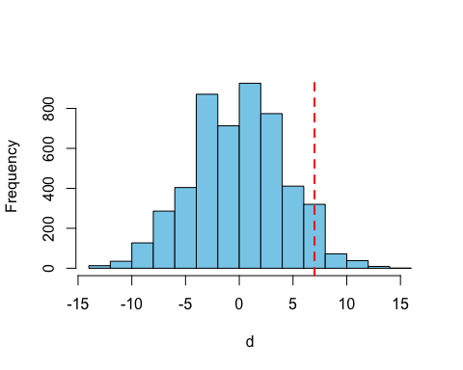

# One sided test, so p-value calculation uses one side of the distribution  
# The +ve side is used since mu2 - mu1 > 0  
pVal <- mean(d > cs)

# Wilcoxon and Confidence Interval example

# Confidence intervals  
# The luxury of a known populations; use normal distribution  
x <- rnorm(50, 15) # actual pop mean = 15  
y <- rnorm(50, 10) # actual pop mean = 10  
# difference in means is actually 5  
# but we pretend we don't know that!  
  
wilcox.test(x, y) # Are they different; absolutely

##   
## Wilcoxon rank sum test with continuity correction  
##   
## data: x and y  
## W = 2500, p-value < 2.2e-16  
## alternative hypothesis: true location shift is not equal to 0

wilcox.test(x, y, alternative = 'l') # Is x < y, no way

##   
## Wilcoxon rank sum test with continuity correction  
##   
## data: x and y  
## W = 2500, p-value = 1  
## alternative hypothesis: true location shift is less than 0

wilcox.test(x, y, alternative = 'g') # Is x > y, absolutely

##   
## Wilcoxon rank sum test with continuity correction  
##   
## data: x and y  
## W = 2500, p-value < 2.2e-16  
## alternative hypothesis: true location shift is greater than 0

# Generate estimate of population difference in means  
p <- mean(x) - mean(y)  
p

## [1] 4.752681

# Determine a confidence interval for the difference between x and y  
# Generate confidence interval for true difference in population means  
d <- replicate(10000,  
 {  
 ix <- sample(1:length(x), replace = TRUE)  
 iy <- sample(1:length(y), replace = TRUE)  
   
 mean(x[ix]) - mean(y[iy])  
 })  
  
hist(d)  
abline(v = 5, col = 2, lwd = 2, lty = 2)  
  
# calculate 95% confidence interval  
q <- quantile(d, c(0.025, 0.975))  
q

## 2.5% 97.5%   
## 4.376405 5.123247

abline(v = q, col = 'purple', lwd = 3, lty = 3)

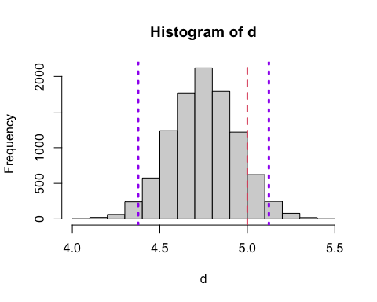

# Confidence interval - Birth Weight

# Confidence interval for maternal smoking dataset  
df <- read.csv('../datasets/birthwt.csv')  
  
# Extract entire data set into the two groups  
no <- subset(df$bwt, df$smoke == 'no')  
yes <- subset(df$bwt, df$smoke == 'yes')  
  
# Difference means for the sample;  
# estimate of difference in population  
res <- mean(no) - mean(yes)  
  
## Alternal approach: delta <- aggregate(bwt~smoke, df, mean)  
# resample using "boostrapping"  
d <- replicate(1000,  
 {  
 # bootstrapping means doing the following:  
 # - create new sample of same size as original  
 # - must use replacement;  
 # otherwise we generate a shuffled original!  
 # - must preserve group sizes; 472 no smoke, 484 smoke  
 # so doing the two samples! Don't want to induce differences  
 ns <- sample(no, replace = TRUE)  
 s <- sample(yes, replace = TRUE)  
   
 # difference in means  
 mean(ns) - mean(s)  
 })  
  
# find boundaries for central 95% of the data  
q <- quantile(d, c(0.025, 0.975))  
q # conf interval, range within which true pop. difference is expected to reside

## 2.5% 97.5%   
## 196.4152 313.0799

# visualise as matter of interest  
hist(d,  
 main = 'Confidence Interval\nfor\ndifference in means',  
 xlab = 'Difference in means')  
abline(v = res, col = 'blue', lwd = 2) # point estimate of pop mean  
abline(v = q, col = 'purple', lwd = 2, lty = 3) # show confidence interval

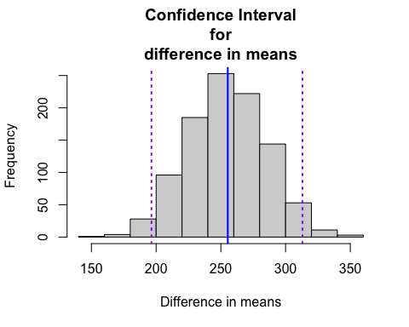

# Binomial Confidence Interval - Method 1

# Bootstrap binomial confidence intervals for true rate in pop.  
# Method 1  
germinate <- 1  
notGerminate <- 0  
  
seeds <- c(rep(germinate, 15),  
 rep(notGerminate, 5))  
  
d <- replicate(1000,  
 {  
 res <- sample(seeds, replace = TRUE)  
 mean(res)  
 })  
mean(d)

## [1] 0.74995

q <- quantile(d, c(0.025, 0.975))  
q

## 2.5% 97.5%   
## 0.55000 0.90125

# use of expression allows showing Greek letter  
hist(d, col = 'skyblue', xlab = expression(rho),  
 main = 'Proportion of seeds\nthat germinate')  
abline(v = q, col = 2, lwd = 2, lty = 2)

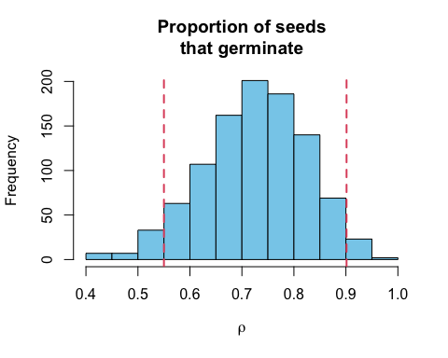

# Binomial Confidence Interval - Method 2

# Method 2  
d <- rbinom(1000, size = 20, prob = 15/20)  
d <- d / 20  
  
mean(d)

## [1] 0.7536

q <- quantile(d, c(0.025, 0.975))  
q

## 2.5% 97.5%   
## 0.55 0.95

hist(d, col = 'skyblue', xlab = expression(rho),  
 main = 'Proportion of seeds\nthat germinate')  
abline(v = q, col = 2, lwd = 2, lty = 2)

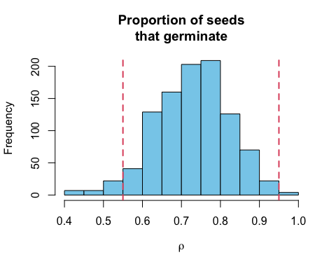

# Poison distribution confidence interval

# Calculate Poisson confidence interval for true pop. lambda / expected death rate  
horsekick <- c(109, 65, 22, 3, 1)  
deaths <- rep(0:4, horsekick)  
  
d <- replicate(1000,  
 {  
 res <- sample(deaths, replace = TRUE)  
 mean(res)  
 })  
mean(d)

## [1] 0.611905

q <- quantile(d, c(0.025, 0.975))  
q

## 2.5% 97.5%   
## 0.51 0.72

hist(d, col = 'skyblue', xlab = expression(rho),  
 main = 'Proportion of deaths\nby horse kick')  
abline(v = q, col = 2, lwd = 2, lty = 2)

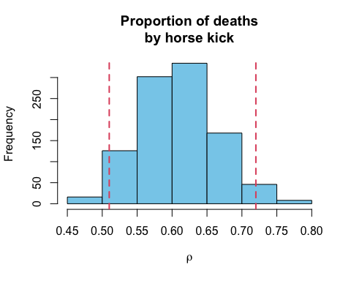

# Crabs data - Correlation hypothesis

# Slide 4  
df <- read.csv('../datasets/crabsmolt.csv')  
  
plot(df$postsz ~ df$presz, pch = 19, col = 1,   
 xlab = 'presz', ylab = 'postsz')

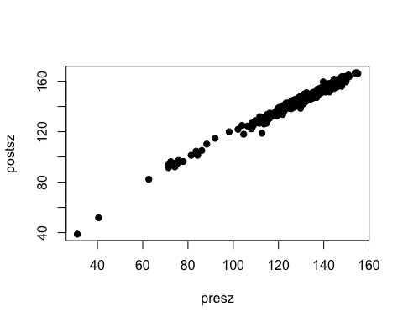

cor(df$presz, df$postsz)

## [1] 0.9903699

obs.cor = cor(df$presz, df$postsz)  
x= replicate(1000, {  
 post.perm = sample(df$postsz)  
 cor(df$presz, post.perm)  
})  
  
sum(abs(x) > abs(obs.cor))/1000

## [1] 0

cor.test(df$presz, df$postsz, method = "pearson")

##   
## Pearson's product-moment correlation  
##   
## data: df$presz and df$postsz  
## t = 155.08, df = 470, p-value < 2.2e-16  
## alternative hypothesis: true correlation is not equal to 0  
## 95 percent confidence interval:  
## 0.9884701 0.9919580  
## sample estimates:  
## cor   
## 0.9903699

# Linear Models - Hypothesis testing - slope = 0

# Slide 4  
df <- read.csv('../datasets/crabsmolt.csv')  
  
fit = lm(postsz~presz, data = df)  
summary(fit)

##   
## Call:  
## lm(formula = postsz ~ presz, data = df)  
##   
## Residuals:  
## Min 1Q Median 3Q Max   
## -15.4269 -1.1611 -0.0669 1.2169 5.9251   
##   
## Coefficients:  
## Estimate Std. Error t value Pr(>|t|)   
## (Intercept) 25.802580 0.767201 33.63 <2e-16 ***  
## presz 0.913965 0.005893 155.08 <2e-16 ***  
## ---  
## Signif. codes: 0 '***' 0.001 '**' 0.01 '*' 0.05 '.' 0.1 ' ' 1  
##   
## Residual standard error: 2.029 on 470 degrees of freedom  
## Multiple R-squared: 0.9808, Adjusted R-squared: 0.9808   
## F-statistic: 2.405e+04 on 1 and 470 DF, p-value: < 2.2e-16

plot(postsz ~ presz, data=df, pch=16)  
abline(fit, col = 2)

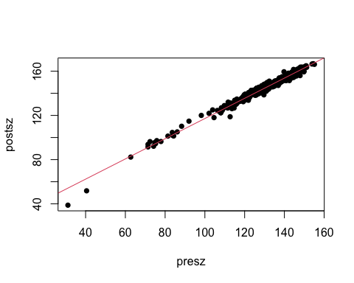

## Hypothesis for slope = 0  
  
## compute the slope of the data  
cs <- coef(fit)[2]  
## compute the slope if the population b = 0  
x= replicate(5000, {  
 presz.perm = sample(df$presz) # shuffle one variable to force population b = 0  
 fit = lm(postsz ~ presz.perm, data=df) # fit the straight line model  
 coef(fit)[2] # return the fitted b  
})  
## examine the distribution of b, when the population b = 0  
hist(x, col="lightblue", main="", xlab="", xlim = c(-1,1))  
abline(v = cs, col = 2)

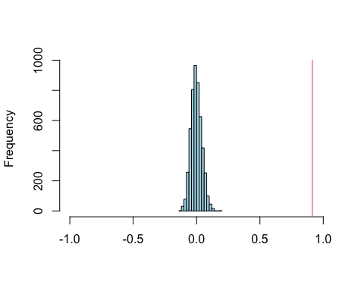

## compute the chance of getting the data b, if the population b = 0  
(pValue = mean(x > abs(cs)) + mean(x < -abs(cs)))

## [1] 0

# Linear Models - Hypothesis testing - Slope = 1

# Slide 4  
df <- read.csv('../datasets/crabsmolt.csv')  
## Hypothesis for slope = 1  
  
## compute the estimate of b - 1 from the data  
fit = lm((postsz - presz) ~ presz, data = df)  
cs = coef(fit)[2]  
## compute many sample gradients, when the population gradient is 1  
x= replicate(5000, {  
 presz.perm = sample(df$presz) # shuffle one variable  
 fit = lm((postsz - presz) ~ presz.perm, data = df) # fit the model  
 coef(fit)[2] # return the estimate of b  
})  
## examine the distribution of b - 1, when the population b = 1  
hist(x, col="lightblue", main="", xlab="", xlim = c(-0.1,0.1))  
abline(v = cs, col = 2)

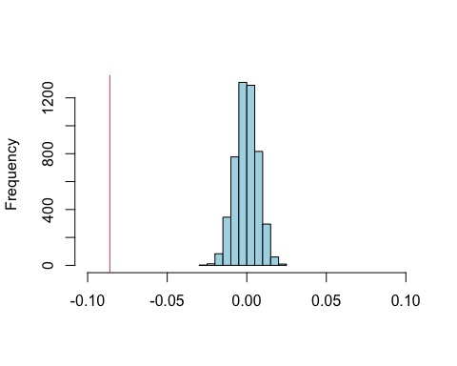

## compute the chance of getting the data b, if the population b = 1  
(pValue = mean(x > abs(cs)) + mean(x < -abs(cs)))

## [1] 0

## Conclusion - Assuming the slope is 1, the probability of seeing   
## a slope at least this extreme by mere chance is practically 0.   
## It is concluded that the slope is not equal to 1.

# Linear Models - Confidence interval

# Slide 4  
df <- read.csv('../datasets/crabsmolt.csv')  
  
n = nrow(df) # store the number of observations n  
## compute a set of bootstrap samples of b  
x= replicate(5000, {  
 samp = sample(1:n, replace = TRUE, size = n) # sample the row numbers (with replacement)  
 # fit the regression model to the selected rows (samp) of the data  
 fit = lm(postsz ~ presz, data = df[samp,])  
 coef(fit)[2] # extract the estimate of b  
})  
## examine the bootstrap distribution of b  
hist(x, col = "lightblue", main = "", xlab = "")  
## add the interval lines  
abline(v = quantile(x,c(0.025, 0.975)), col = "blue", lwd = 2)

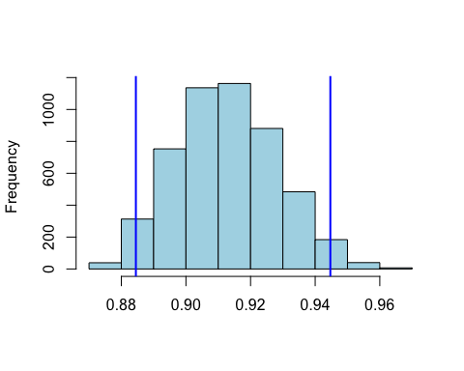

## print out the interval boundaries (95% interval)  
quantile(x, c(0.025, 0.975))

## 2.5% 97.5%   
## 0.8845042 0.9446943

# QQ - Plot

# Slide 12  
# QQ plot  
#  
# y is the data being considered evaluated  
# x is the normally distributed data being used as a reference  
  
n <- 10 # Try different sample sizes  
y <- rnorm(n)  
# y <- rexp(n) # could try other distributions  
  
# Order / sort the values  
y <- sort(y)  
  
# P(Z < zi) = i / (n + 1)  
# x represents probabilities (0, 1)  
# BUT zero and one are not included  
x <- 1:length(y) / (length(y) + 1)  
  
# Convert the x values (probabilities) to x axis locations  
x <- qnorm(x)  
  
# Our crude version of a QQ plot  
plot(y ~ x)  
  
# intercept of zero, slope of one  
# crude, probability not the best fit  
abline(coef = 0:1)

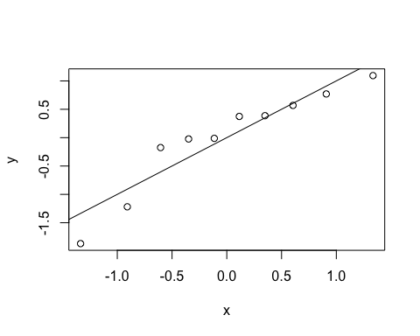

# built in functions to do this  
# compare with above  
qqnorm(y) # plot the QQ-plot  
qqline(y) # add the line to the plot showing Normality

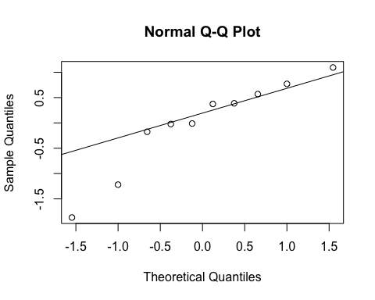

# better version  
# An alternative is to use the car add-on library:  
library(car)

## Loading required package: carData

qqPlot(y) # plot a QQ-plot with a line

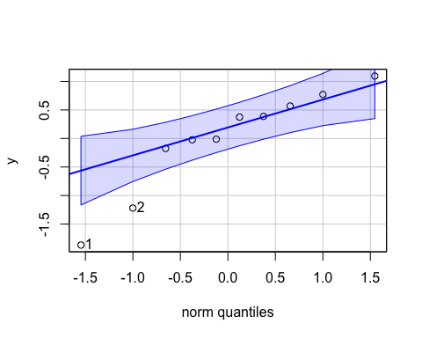

## [1] 1 2

## Birth weight QQ - Normal plot

birthwt = read.csv("../datasets/birthwt.csv")  
with(birthwt, qqPlot(bwt[smoke=="yes"], main="Smokers"))

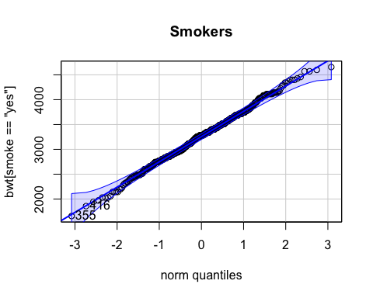

## [1] 355 416

with(birthwt, qqPlot(bwt[smoke=="no"], main="Non Smokers"))

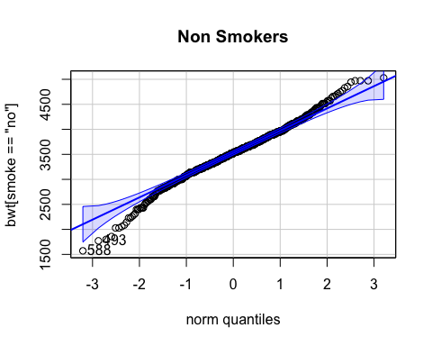

## [1] 588 493

# T-test Birth weight

df <- read.csv('../datasets/birthwt.csv')  
  
aggregate(df$bwt, list(df$smoke), length)

## Group.1 x  
## 1 no 742  
## 2 yes 484

aggregate(df$bwt, list(df$smoke), mean)

## Group.1 x  
## 1 no 3515.639  
## 2 yes 3260.285

aggregate(df$bwt, list(df$smoke), sd)

## Group.1 x  
## 1 no 497.0966  
## 2 yes 517.1097

# or  
aggregate(bwt ~ smoke, df, sd)

## smoke bwt  
## 1 no 497.0966  
## 2 yes 517.1097

# Assuming equal variances in the populations  
t.test(df$bwt ~ df$smoke, var.equal = TRUE,  
 alternative = 't') # H1: mu1 <> mu2

##   
## Two Sample t-test  
##   
## data: df$bwt by df$smoke  
## t = 8.6527, df = 1224, p-value < 2.2e-16  
## alternative hypothesis: true difference in means between group no and group yes is not equal to 0  
## 95 percent confidence interval:  
## 197.4554 313.2520  
## sample estimates:  
## mean in group no mean in group yes   
## 3515.639 3260.285

t.test(df$bwt ~ df$smoke, var.equal = TRUE,  
 alternative = 'l') # H1: mu1 < mu2

##   
## Two Sample t-test  
##   
## data: df$bwt by df$smoke  
## t = 8.6527, df = 1224, p-value = 1  
## alternative hypothesis: true difference in means between group no and group yes is less than 0  
## 95 percent confidence interval:  
## -Inf 303.9322  
## sample estimates:  
## mean in group no mean in group yes   
## 3515.639 3260.285

t.test(df$bwt ~ df$smoke, var.equal = TRUE,  
 alternative = 'g') # H1: mu1 > mu2

##   
## Two Sample t-test  
##   
## data: df$bwt by df$smoke  
## t = 8.6527, df = 1224, p-value < 2.2e-16  
## alternative hypothesis: true difference in means between group no and group yes is greater than 0  
## 95 percent confidence interval:  
## 206.7752 Inf  
## sample estimates:  
## mean in group no mean in group yes   
## 3515.639 3260.285